Texas History – 7th grade – 2015-2016

Mark Anderson
Mark.Anderson@fortbendisd.com

Conference: 2:20-2:50 p.m. daily or e-mail for an appointment

Grading Policy

Tests/Projects 50% -- At least three major grades will be given during the nine weeks.
*It is district policy for students who score below a 70 on a test to attend a tutorial and then retest for a grade not exceeding an 80.

Quizzes/Classwork/, etc 50% - There will be
at least four daily grades every grading cycle.
Unannounced quizzes can occur at any time.
Reading quizzes are open book.

Tutorial

Tutorials will be offered every Wednesday from 8:15-8:45am if needed. The sessions are to help students having difficulty with specific skills or assignments or make-up for absences. In order for tutorials to be useful, students need to come prepared with specific questions. They will be expected to be on time (8:15 AM and no later than 8:30AM).

Expectations:

Be ready, responsible, and respectable.

Let’s have a great year.

Late Work Policy
1st day – 10 points deducted
2nd day – 20 points deducted
3rd day – 30 points deducted
After 3rd day - teacher discretion

Gators…
Respect themselves
Respect others
Respect property

Make-Up Work:

Students are responsible for obtaining and completing all notes and make-up work when absent. See the Student Handbook for turn-in policy. After the make-up time expires, the students will be given the same options under the late work policy above. Test make-up must be done during tutorial or appointments
I am looking forward to an exciting year and to prepare you for your passage to eighth grade and high school!
Ms. Clinkscales
Hind sight is 20/20; learn from our past and improve our future!
Learning and understanding our history is the key!

Tutorial Schedule

Thursday: 4:00-5:00 p.m.
Friday: 8:15 – 8:45 a. m.

Make-up work/test maybe completed

NHD tutorial held in the school library on Wednesday 4:00-5:00 P.M.

Homework:

Student’s homework will vary.
Home work will be done using the online textbook.
This is accessible through the website
www.connected.mcgraw-hill.com
user id-FBISD******(lunch#)
password-FBISD******(lunch#)

The six flags that have flown over Texas
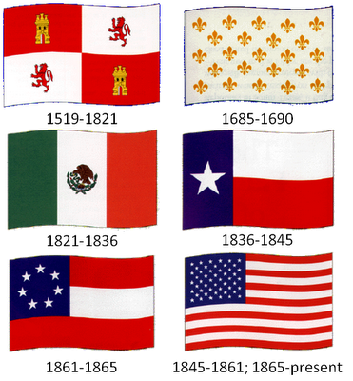

Flags during the Texas Revolution



